**GROUP 6 – INFLUENCE OF MUSIC: AN EXPLORATORY STUDY**

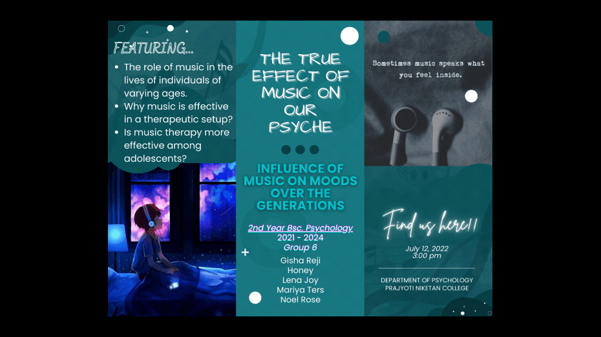The Community Project presented by Group 6 tackled the influence of music on the human psyche. The project was presented by Gisha Reji, Lena Joy, Honey, Mariya Ters, and Noel Rose. It was presented on July 22nd, 2022 at the 3rd year psychology classroom at 2:30 pm.

Music was first defined as a sound that conveys emotion. The study ventured to answer the following questions:

* + What is the role of music in the lives of individuals of varying ages?
  + Why music is effective in a therapeutic setup?
  + Is music in therapy is more effective among adolescents?

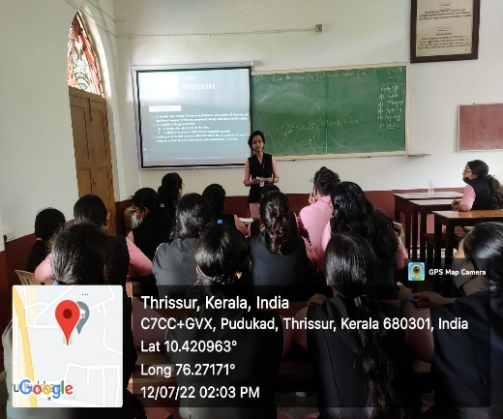These questions were answered using the semi-structured interview method and through the collection and analysis of secondary data. Data was collected from 30 individuals belonging to the following 3 generations:

* Generation 1: 1960-1980
* Generation 2: 1980-2000
* Generation 3: 2000-present

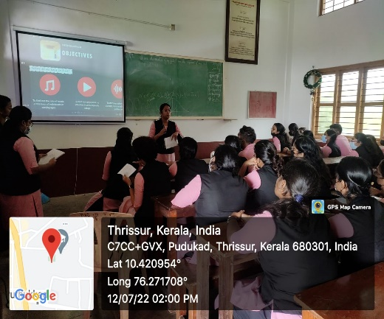There were a total of 12 self constructed questions which were developed in order to analyse the influence of music on mental health and emotions of different generations. In addition to self constructed questions probing questions were also asked.

Secondary data such as experiments and studies conducted were collected and analysed to find the benefits of using music in a therapeutic setup and to understand the relationship between effectiveness of music therapy and age.

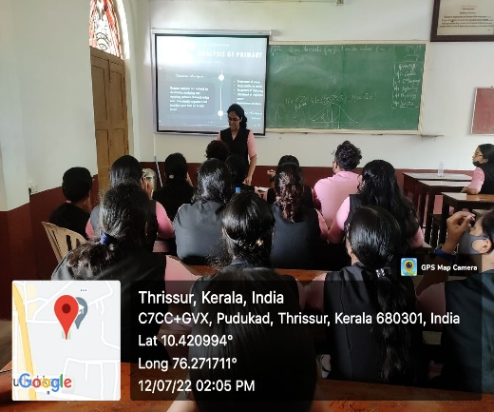The study was concluded by presenting the following findings:

* The relationship between music and mental health is significantly stronger among the youngest generation.
* The interest in music and the frequency of listening to music is highest among the adolescent generation.
* The younger generations depend on music for a variety of activities (along with mood regulation) while the older generations mainly associate songs with nostalgia.
* It was found that music is highly effective in a therapeutic setup due to its benefits in reducing stress, pain and bringing psychological peace.
* It was found that music as a form of therapy is potentially more effective among adolescents due its wider range of applications and variety of benefits unique to the adolescent population.

